1. Bacteria are classified into which domain?
a. Archaea
*b. Bacteria
c. Eukarya
d. Protista
e. None of the above

2. Bacteria and archaeans are
a. eukaryotic
*b. prokaryotic

3. Which of these organisms is photosynthetic?
a. Clostridium
b. Lactobacillus
*c. Nostoc
d. all of these
e. none of these

4. Which of these organisms has chloroplasts?
a. Clostridium
b. Lactobacillus
c. Nostoc
d. all of these
*e. none of these

5. Which of these organisms have chlorophyll?
a. Clostridium
b. Lactobacillus
*c. Nostoc
d. all of these
e. none of these

6. Which of these organisms have mitochondria?
a. Clostridium
b. Lactobacillus
c. Nostoc
d. all of these
*e. none of these

7. On the diagram below, the structure labeled “a” is a
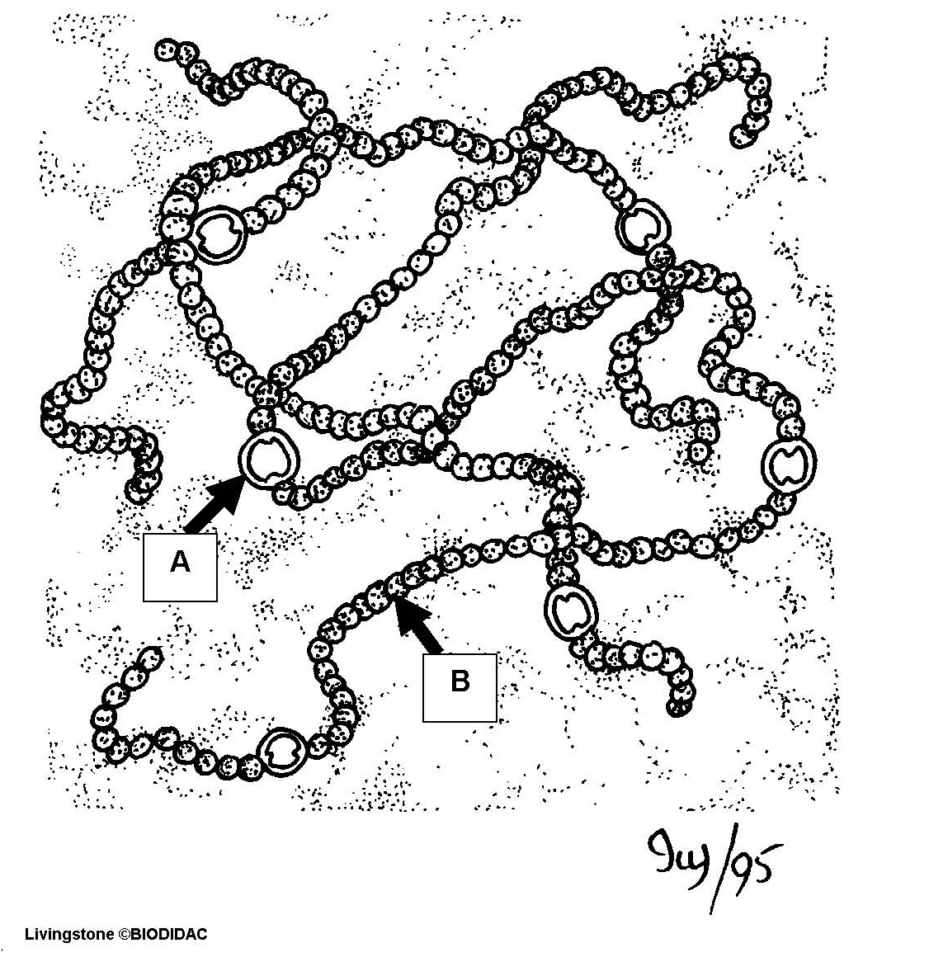

a. fimbria
b. flagellum
*c. heterocyte
d. vegetative cell

8. On the diagram below, the structure at the tip of the pointer is a
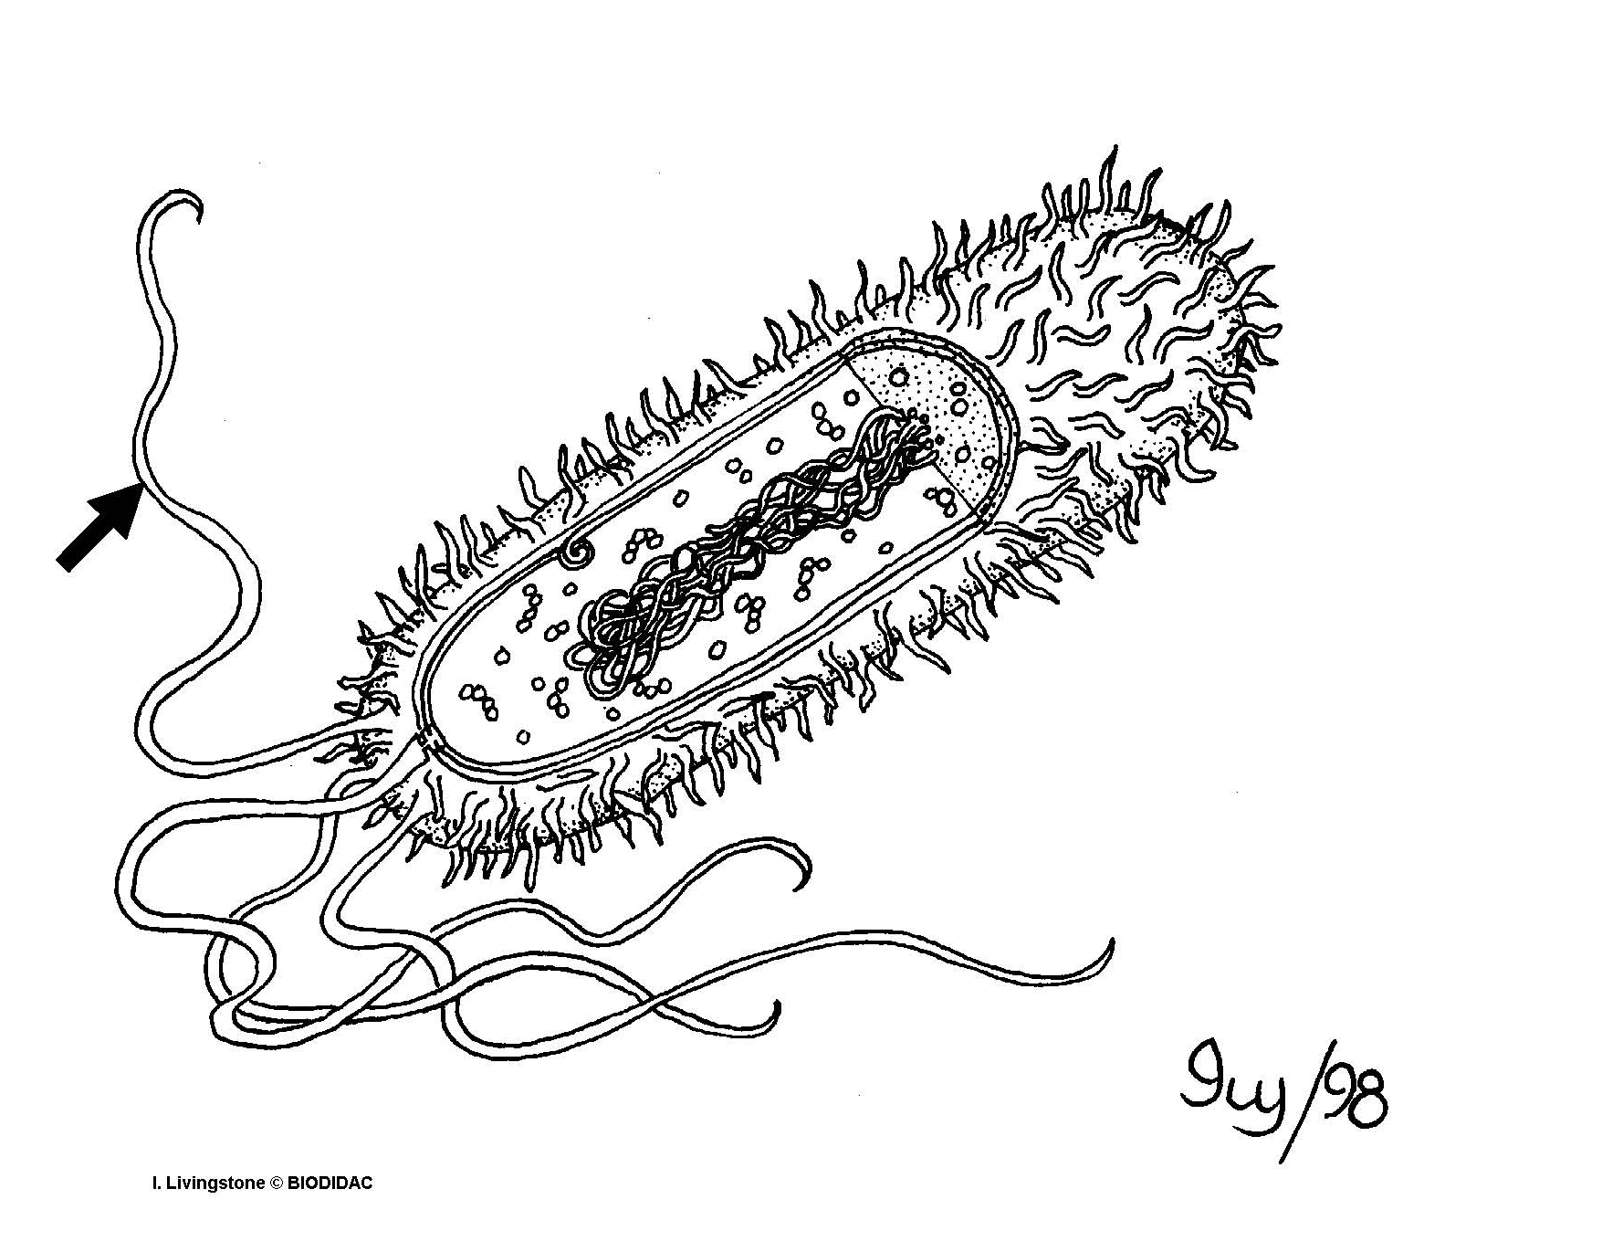

a. fimbria
*b. flagellum
c. heterocyte
d. vegetative cell

9. On the diagram below, the structure labeled “b” is a

a. fimbria
b. flagellum
c. heterocyte
*d. vegetative cell

